Professor’s Name
Student’s Name
Course Title
Date

Question 1: Find a 2 x 2 matrix that maps e₁ to –e₂ and e₂ to e₁+3e₂.

Given:
A linear transformation $T:$ R²$→$R²

Such that T (e₁) = - e₂ and T (e₂ ) = e₁ + 3e₂
_{Where}
Where e₁ ₌ $\left[\begin{aligned}1 \\ 0\end{aligned}\right]$ and e₂= $\left[\begin{aligned}0 \\ 1\end{aligned}\right]$
To find;
The 2x2 matrix for the given Map.
Solution:
T (e₁) = - e₂
= ₋₋ $\left[\begin{aligned}0 \\ 1\end{aligned}\right]$
T (e₁) = $\left[\begin{aligned}0 \\ -1\end{aligned}\right]$ …………….. (1)
T (e₂) = (e₁) + 3e₂
= $\left[\begin{aligned}1 \\ 0\end{aligned}\right]$ + 3 $\left[\begin{aligned}0 \\ 1\end{aligned}\right]$
= $\left[\begin{aligned}1 \\ 0\end{aligned}\right]$ +$\left[\begin{aligned}0 \\ 3\end{aligned}\right]$
T (e₂) = $\left[\begin{aligned}1 \\ 3\end{aligned}\right]$……………….. (2)
Hence, the required Matrix of T is $\left[\begin{aligned}0 1 \\ -1 3\end{aligned}\right]$
Question 2: Consider the linear transformation described by the matrix$A=\left[\begin{matrix}1 & 1 \\ 0 & 1\end{matrix}\right]$. Note that arbitrary points on the x-axis can be written as $\left[\begin{matrix}s \\ 0\end{matrix}\right]$ for $s∈ R$ and arbitrary points on the y-axis can be written as $\left[\begin{matrix}0 \\ t\end{matrix}\right]$ for$t∈ R$. To what set of points does this transformation map the x-axis to? To what set of points does this transformation map the y-axis to?
Solution:
Let A = $\left[\begin{aligned}1 1 \\ 0 1\end{aligned}\right]$ . Consider B = $\{ {\left.\left(\begin{aligned} 1 \\ 0 \end{aligned}\right.\right)}^{ },{\left.\left(\begin{aligned}0 \\ 1\end{aligned}\right.\right)}^{ }\}$ be basis of $R2$
Let T be Matrix Corresponding to Matrix A.
Then, T $\left.\left(\begin{aligned}1 \\ 0\end{aligned}\right.\right)$ =1 $\left.\left(\begin{aligned}1 \\ 0\end{aligned}\right.\right)$+ 0 $\left.\left(\begin{aligned}0 \\ 1\end{aligned}\right.\right)$ =$\left.\left(\begin{aligned}1 \\ 0\end{aligned}\right.\right)$
And T $\left.\left(\begin{aligned}0 \\ 1\end{aligned}\right.\right)$ = 1 $\left.\left(\begin{aligned}1 \\ 0\end{aligned}\right.\right)$+ 1$\left.\left(\begin{aligned}0 \\ 1\end{aligned}\right.\right)$ =$\left.\left(\begin{aligned}1 \\ 1\end{aligned}\right.\right)$
Now for any x, y,,
T (x, y) = T(x$\left.\left(\begin{aligned}1 \\ 0\end{aligned}\right.\right)+y\left.\left(\begin{aligned}0 \\ 1\end{aligned}\right.\right)$ ) = xT$\left.\left(\begin{aligned}1 \\ 0\end{aligned}\right.\right)$+ yT$\left.\left(\begin{aligned}0 \\ 1\end{aligned}\right.\right)$= x $\left.\left(\begin{aligned}1 \\ 0\end{aligned}\right.\right)$+ y$\left.\left(\begin{aligned}1 \\ 1\end{aligned}\right.\right)$= $\left.\left(\begin{aligned}x+y \\ y \end{aligned}\right.\right)$
Thus, the linear transformation on is T(x, y) =$\left.\left(\begin{aligned}x+y \\ y \end{aligned}\right.\right)$.
Let $\left[\begin{aligned}s \\ 0\end{aligned}\right]$ be any point on x-axis.
Then, T $\left.\left(\begin{aligned}s \\ 0\end{aligned}\right.\right)$= $\left.\left(\begin{aligned}s+0 \\ 0\end{aligned}\right.\right)$ =$\left.\left(\begin{aligned}s \\ 0\end{aligned}\right.\right)$, same point
and T $\left.\left(\begin{aligned}0 \\ t\end{aligned}\right.\right)$ =$\left.\left(\begin{aligned}0+t \\ t\end{aligned}\right.\right)$ =$\left.\left(\begin{aligned}t \\ t\end{aligned}\right.\right)$
Thus, T maps the set of points on x- axis to the same points on x-axis. And the set of points on y-axis to the set of points {(t, t): }
Question 3: Define the unit square as the collection of points in $R^{2}$ with vertices (0, 0), (0, 1), (1, 0), and (1, 1). Sketch the unit square.

Solution
Given that the vertices of the square are O (0, 0), A (0, 1), B (1, 1) and C (1, 0)
- The equation of the line joining O (0,0) and A (0,1) is x=0
- The equation of the line joining A (0,1) and B(1,1),is y=1
- The equation of the line joining B(1,1) and C(1,0) is x=1
- The equation of the line joining C (1,0) and O(0,0) is y=0
Therefore the equation of the square is the set of all points (x, y) such that
0≤x≤1, 0 ≤ y ≤ 1.
And the graph is; draw the line joining O(0,0) and A(0,1) is the line x=0 on Y-axis, then to draw the line joining B (1,1) and C (1,0) is the line x= 1 (parallel to Y-axis) and finally draw the line joining C(1,0) and O(0,0) is the line y=0 on X-axis.
The sketch is as show below;
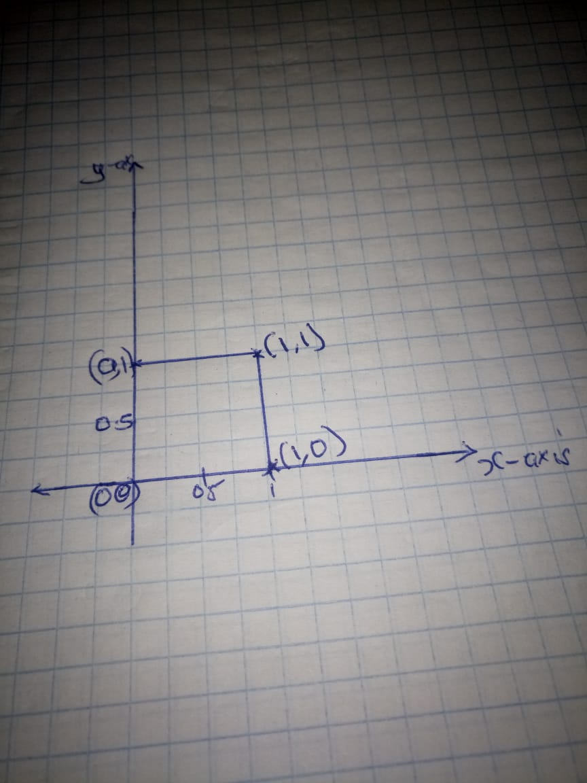
Question 4: For each of the following linear transformation matrices, sketch the transformation of the unit square.

$$A_{1}=\left[\begin{matrix}2 & 0 \\ 1 & 1\end{matrix}\right], A_{2}=\left[\begin{matrix}0 & 1 \\ -1 & 0\end{matrix}\right], A_{3}=\left[\begin{matrix}cos⁡(π/4) & -sin⁡(π/4) \\ sin⁡(π/4) & cos⁡(π/4)\end{matrix}\right]$$
Solution:
The Unit square formed with (1, 0), (0, 1), (1, 1) and (1, 1)
- Let A₁ = $\left[\begin{matrix}2 & 0 \\ 1 & 1\end{matrix}\right]$
The linear transformation corresponding to A₁ is
T (x,y) =T ( x(1,0)+y(0,1) ) =XT (1,0)+Yt(0,1)= x(2,1)+y (0,1)=(2x,x+y)
Thus, T(x, y) = (2x, x+y).
Now T (0,0) =(0,0),T(1,0)=(2,1),T(0,1)=(0,1),T(1,1) =(2,2)
Hence, the image of Unit Square is formed by
{(0,0),(0,1),(2,1),(2,2)}.
The sketch is as shown below: 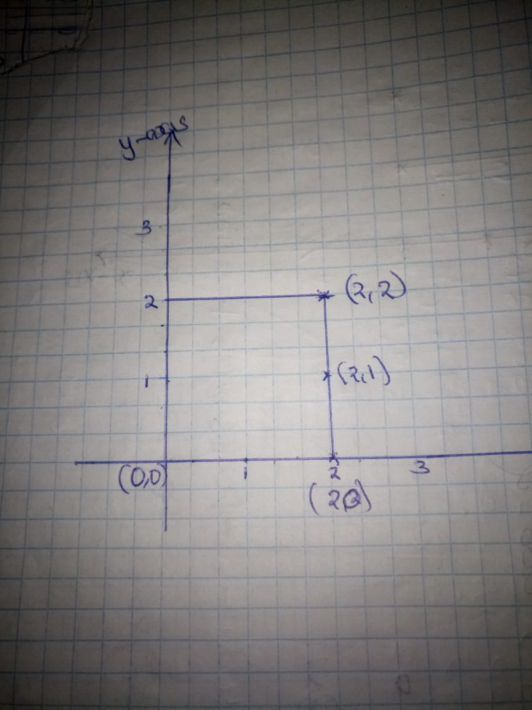

2.
Let A₂ =$\left[\begin{matrix}0 & 1 \\ -1 & 0\end{matrix}\right]$
The linear transformation corresponding to A₂ is
T (x,y) =T (x(1,0)+y(0,1)) =xT (1,0)+yT(0,1)= x(0,-1)+y (1,0)=(y,-x)
Thus, T (x, y) = (y,-x)
Now T(0,0)=(0,0),T(1,0)=(0,-1),T(0,1)=(1,0),T (1,1)=(1,-1)
Hence, the image of unit Square is formed by
{(0,0),(0,-1),(1,0),(1,-1)}.
The sketch of the image is as shown:
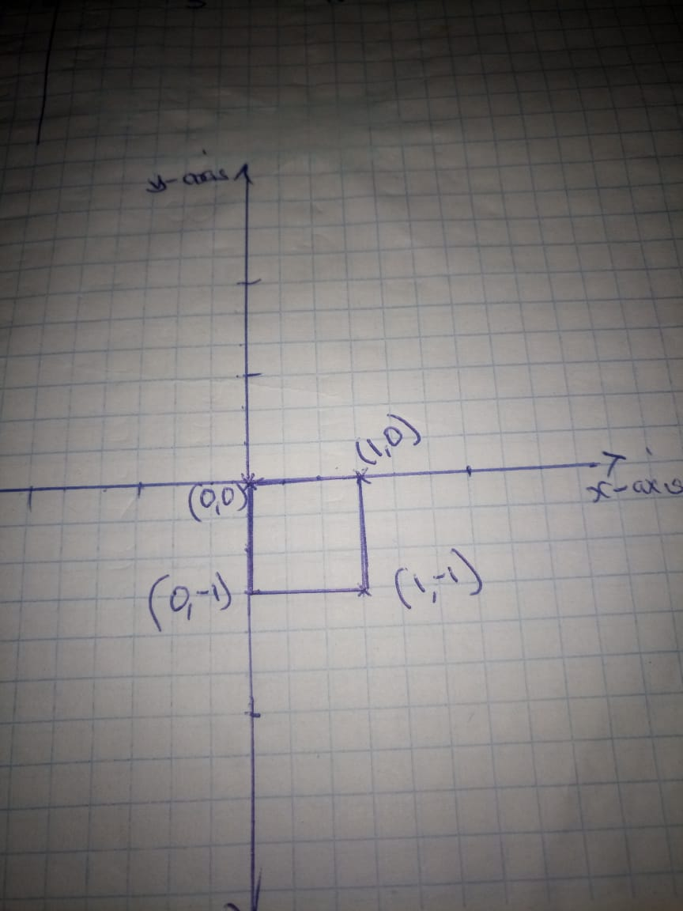
3. Let A₃
$${\left[\begin{aligned} \cos\left(\frac{π}{4}\right)-sin⁡( \frac{π}{4}) \\ \\ Sin\left(\frac{π}{4}\right) Cos (\frac{π}{4}) \\ \end{aligned}\right]}^{}$$
The linear transformation on corresponding to A₂ is
T (x,y) =T (x(1,0)+y(0,1)) =xT (1,0)+yT(0,1)
=x (cos ($\frac{π}{4}$), Sin ($\frac{π}{4}$)) +y (-Sin ($\frac{π}{4}$), Cos ($\frac{π}{4}$))
= (x cos ($\frac{π}{4}$)-y sin ($\frac{π}{4}$), x sin ($\frac{π}{4}$) +ycos ($\frac{π}{4}$))
Thus(x, y) = (xcos ($\frac{π}{4}$)-ysin ($\frac{π}{4}$), xsin ($\frac{π}{4}$) +ycos ($\frac{π}{4}$))
Now T(0,0)=(0,0),T(1,0)= ($\frac{ 1}{\sqrt{2}} ,\frac{ 1}{\sqrt{2}}$),T(0,1)=(-$\frac{ 1}{\sqrt{2}} ,\frac{ 1}{\sqrt{2}}$),T(1,1)=($0,\sqrt{2}$ )
Hence, the image of unit square is formed by:
{(0, 0), ($\frac{ 1}{\sqrt{2}} ,\frac{ 1}{\sqrt{2}}$), (-$\frac{ 1}{\sqrt{2}} ,\frac{ 1}{\sqrt{2}}$), ($0,\sqrt{2}$ )}
The sketched image is as shown below:
Question 5: Find a transformation matrix that maps the unit square to the parallelogram with vertices (0, 0), (2, 4), (1, 3), and (3, 7).

Solution :
First we need to identify which of the vertices of the parallelogram are opposite to each other. Clearly (3, 7) is opposite to (0, 0) and (2, 4) is opposite to (1, 3) [the sum of the x co-ordinates of two opposite vertices is equal; and so is the sum of the y-co-ordinates].
The transformation needs to be a linear transformation:
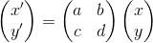
We have the two column vectors to map: (1, 0) T and (0, 1) T. Then if their transformations are to be (2, 4) and (1, 3) respectively [we could have selected (1, 3) and (2, 4) respectively, that will result in a negative determinant] then we must have
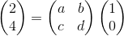 and 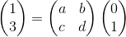
Noticing the similar forms of the two expressions above, we note that we can concatenate two column vectors row-wise to write as a 2x2 matrix [matrix multiplication ensures that the relations derived remain unchanged]:

But the matrix on the right-hand side is the 2x2 identity matrix, hence we get our (one possible) required transformation matrix to be:
